Steps to find information about your Ed plan

You will need your SRJC Student Identification Number (SID # - 9 digits) and your SRJC password (Pin Code)

**STEP 1:** Open a web browser (i.e. Google) and go to the Santa Rosa College webpage [www.santarosa.edu](http://www.santarosa.edu), click on **LOGIN** and select **Student Portal**– or go directly to [Student Portal Login](https://portal.santarosa.edu/SRWeb/Portal.aspx)

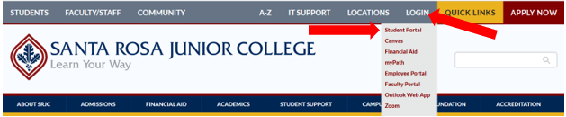

**STEP 2:** Enter your **Username**: 9 digits Student Identification Number (SID#) and your **Password** (PIN). Then click on **Login**.

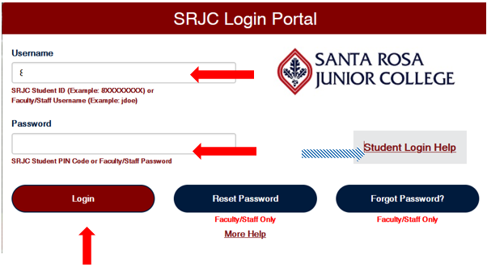

\***If it is the ~~very~~ first time you log in to your student portal**, enter your 8-digit birth date (MMDDYYYY without spaces: 2 digits for month, 2 digits for day, 4 digits for year - i.e. June 20, 1993 = 06201993)) as your temporary PIN. The system will then prompt you to enter your own unique PIN.

**\* If you forgot your Password or PIN**, click on **Student Login Help** on the right side (or bottom) to request your Student ID number or Password. It will be sent to the email address the SRJC has on file for you.

**STEP 3**: Click on **+** sign in the blue ADMISSIONS & REGISTRATION tab to expand it.

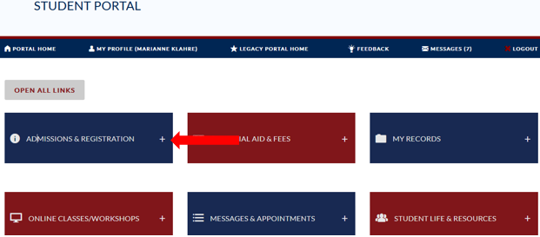

**Step 4:** Under **REGISTER**, select **My Education Plan**

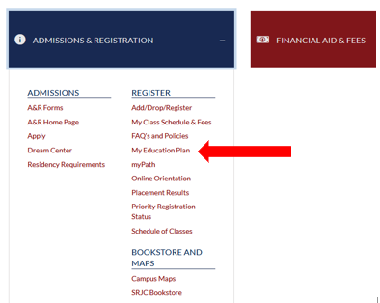

**Step 5:** Scroll down to Academic Plan (ed plan) and find the semester(s) you have an Ed plan for.

In order to gain priority registration for a class in a future semester or semesters, you need to have completed an orientation FIRST (which can be in any semester) and THEN in addition have an Ed plan on file for that semester.

If you want to gain priority for a Summer or Fall class, you need an Ed plan on file for Fall. If you want to gain priority for a Spring class, you need an ed plan on file for Spring.

If you do not have the required ed plan, please visit the front desk at SRJC Roseland, the Santa Rosa or Petaluma Welcome and Connect Center or call 707-527-4229 to schedule a counseling appointment.

If you would like to have a higher priority status, you need to have the appointment with the counselor prior to the Early Bird deadline (last Thursday in March for summer and fall registration and last Thursday in October for spring registration).

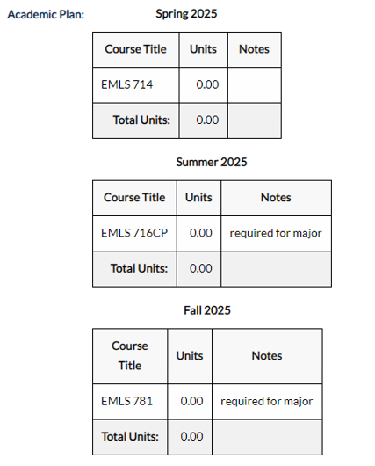

Note: In addition to an Ed plan, you also need to have completed an orientation in order to gain priority registration. Contrary to the Ed plan, you only need to attend an orientation once (not every Fall and Spring semester). To look up if you have completed the orientation, go to Admissions & Registration – Register – See if Orientation has a check mark.

